Effect of porosity on thermal properties of Magnesia.

Mikko Karkkainen

# Introduction

Magnesia (MgO) is widely used as refractory materials in the steel industry. A challenge for refractory design is finding the optimal porosity content. Increasing porosity has the beneficial effect of increasing the thermal resistivity of the material, due to trapped air being a poor thermal conductor. However, it also increases the driving force for sintering, which aggravates the issue of the refractory attaching to the back lining, making removal of the refractory more difficult. Furthermore, higher values of porosity can increase metal penetration of the refractory.

The purpose of this paper is to investigate the thermal behaviour of MgO at porosity values of 10, 30 and 50 vol%. A 1D heat conduction simulation for the system depicted in figure 1 will be carried out. The results will be compared with values taken from the literature. Heat capacity and thermal conductivity will be temperature dependent. Density is assumed independent of temperature. I also assume that no phase transformations take place in the refractory during the heating.

Steel (1600 C)

200 mm MgO (Start= 25 C )

Back lining (25 C)

Figure 1. Schematic for the simulated system

# Thermal properties:

In general, heat evolution in the system will be given by the heat equation:

$$\frac{∂T}{∂t}=\frac{1}{ρ(p)c_{v}\left(T\right)} \frac{∂}{∂x}k(T,p)\frac{∂T}{∂x}$$

Where $k$ is the temperature dependent thermal conductivity, $ρ$ is the density and $c_{v}$ is the temperature dependent heat capacity. To model the system we, need expressions for these three parameters for the materials in question. For this investigation, density $ρ$ is assumed to be independent of temperature, and solely dependent on porosity. For 0% porosity, we use the values:

$$ρ\left(MgO\right)=3.58\frac{g}{cm^{3}}=3580 kg/m^{3}$$

To model density as a function of porosity, we simply use

$$ρ_{tot}=ρ(MgO)⋅(1-p)$$

Where p is the porosity.

## Modelling specific heat capacity

If we assume constant density, we can use the constant volume specific heat capacity $C_{v}$, defined as

$$c_{v}={\left(\frac{∂E}{∂T}\right)}_{v}=\frac{∂}{∂T} {\left(PdV+dQ\right)}_{v}=\frac{∂Q}{∂T}$$

Using the Dulong-Petit law, we imagine the atoms as harmonic oscillators with three degrees of freedom, we get an average energy of $Q=3Nk_{B}T$ for the entire solid. Using the gas constant $R=k_{b}N_{a}$, we get an expression for the molar energy:

$$Q=3RT/mol$$

For $c_{v}$ we get

$$c_{v}=\frac{∂Q}{∂T}=3R/mol$$

This accurately reflects heat capacity for high temperatures. However, at lower temperatures, another model like that given by Debye theory is needed:

$$c_{v}=9Nk{\left[\frac{T}{θ_{D}}\right]}^{3}\int_{0}^{\frac{θ_{D}}{T}}{\frac{x^{4}e^{x}}{{\left(e^{x}-1\right)}^{2}}dx}$$

Where $θ_{D}$ is the characteristic Debye temperature. At the Debye temperature, the equation starts to closely follow the Dulong-Petit law of $c_{v}=3R/mol$.

According to [1], MgO has a Debye temperature of 743 K.

We can numerically integrate the expression to find how $c_{v}$ of MgO evolves with temperature using the scientific calculation module scipy for python. The results are shown in figure 2. For comparison, experimental results from [2] are provided in figure 3. Notice that the units used are different. From figure 3, we can estimate that at 25 C, we have a heat capacity for MgO close to 4.5 cal/mol, which translates to 18.8 J/mol. This is matched very well by our calculation.

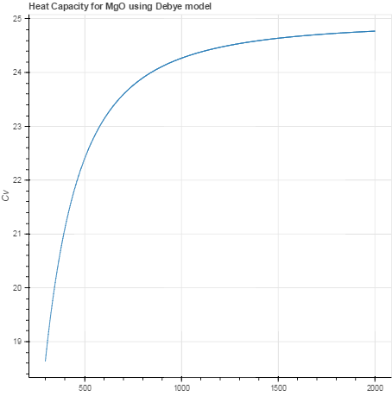

Figure 2 Calculated heat capacity for MgO in J/mol using Debye temperature of 743 K.

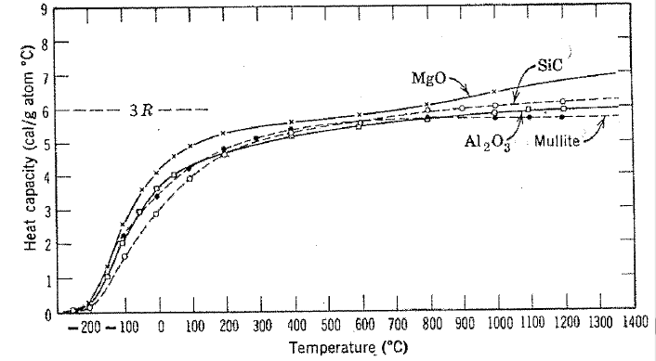

Figure 3 Heat capacity for MgO according to [2]. Notice units cal/mol and temperature in C.

For dependence on $c_{v}$ on porosity, a linear combination of the properties of the gas pore(air) and the solid are used:

$$c_{v_total}=c_{v_solid}⋅vol\%_{solid}+c_{v_{air}}⋅p$$

Where p is the volume fraction of pores. To match our units of $c_{v}$ with our unit of density, we must transform our molar heat capacity to J/(KgK).

The molar weight of MgO $M(MgO)$ is 0.0403 kg/mol. We get the appropriate units by dividing our result by $M(MgO)$

# Thermal conductivity

According to [3], the thermal conductivity of a material can be calculated from kinetic theory:

$$k=\frac{1}{3}c_{v}vl$$

Where $v$ is the mean sound velocity and $l$ is the mean phonon free path. Calculating these properties from first principles using density functional theory, the authors of [3] ended up with the results shown in figure 3. We will use this data to calculate the thermal heat conductivity of the solid.

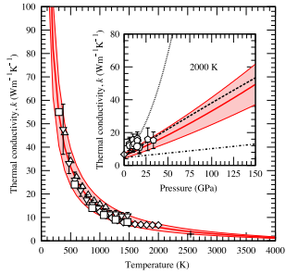

Figure 4 Thermal conductivity of MgO calculated from first principles according to [3].

According to [4], a theoretical model for the apparent thermal conductivity $k(T)$ in a porous material can be calculated as a sum of the effect of several heat transfer mechanisms assumed to act independently:

$$k\left(T,p\right)=Mk_{s}{\left(1-p\right)}^{1.5}+k_{g}p^{0.25}+k_{radiation}$$

$k_{s}$ is thermal conductivity of solid, $k_{g}$ is thermal conductivity of gas, M is a structure coefficient accounting for particle size, volumetric density of grain boundaries and microcracks, grain contact area and gas pressure. $p$ is the porosity. According to [4], almost all refractory materials have $M=0.56±0.15$. The contribution of radiation is usually minor, especially at low to moderate temperatures, and is ignored in this investigation. For gas, we will use data from [5], shown in figure 4.

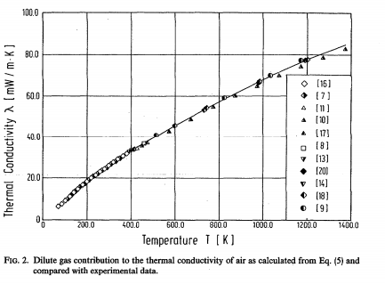

Figure 5. Thermal conductivity of air as a function of temperature. Notice units mW/(mK). [5]

Table 1. Thermal conductivity as function of temperature for MgO after [3] and slope of $Δ$ k/ $Δ$ T

|  |  |  |  |  |  |  |
| --- | --- | --- | --- | --- | --- | --- |
| **T(K)** | 250 | 330 | 420 | 585 | 805 | 1115 |
| **k(W/mK)** | 66.0 | 49.7 | 38.9 | 26.6 | 18.7 | 12.8 |
| **Slope** | -0.21 | -0.12 | -0.07 | -0.04 | -0.02 |  |

Table 2. Thermal conductivity for air after [5]. Also slope for k/T

|  |  |  |  |  |  |  |
| --- | --- | --- | --- | --- | --- | --- |
| **T(K)** | 250 | 330 | 420 | 585 | 805 | 1115 |
| **k(W/mK)** | 0.022 | 0.028 | 0.034 | 0.044 | 0.058 | 0.074 |
| **Slope** | 7.43E-05 | 7.00E-05 | 6.05E-05 | 5.92E-05 | 5.25E-05 |  |

To calculate the thermal conductivity numerically, we will use a stepwise linearization of the data using the slopes we acquired.

For $Tϵ[T_{1},T_{2}]$:

$$k_{s}\left(T,p\right)=0.56⋅\left(k_{s,1}+a\left(T-T_{1}\right)\right){\left(1-p\right)}^{1.5}, a=\frac{k_{s,2}-k_{s,1}}{T_{2}-T_{1}}$$

$$k_{g}\left(T,p\right)=\left(k_{g,1}+b\left(T-T_{1}\right)\right)p^{0.25}, b=\frac{k_{g,2}-k_{g,1}}{T_{2}-T_{1}}$$

$$k_{tot}\left(T,p\right)=\left(T-T_{1}\right)\left(a{\left(1-p\right)}^{1.5}+bp^{0.25}\right)+k_{s,1}{{\left(1-p\right)}^{1.5}+k}_{g,1}p^{0.25}$$

Note that everything except $T$ is a constant for a given temperature range and a given value of porosity. Therefore, we may express it as

$$k_{tot}\left(T\right)=c\left(T-T_{1}\right)+e$$

Where $c$ and $e$ are constants.

We obtain the results shown in figure 6.

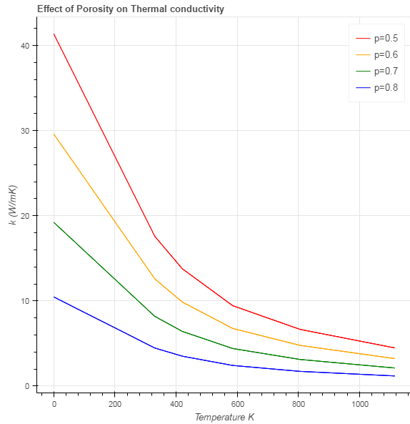

Figure 6 Effect of porosity on thermal conductivity

These can be compared with results shown in figure 7 from [4]. The discrepancy of factor 5 for my results might be explained by me using data for pure MgO periclase, while [4] uses data for commercial refractory materials.

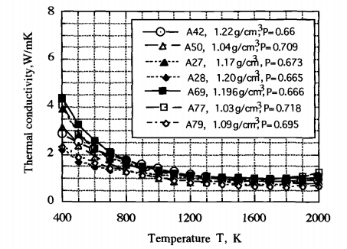

Figure 7. Temperature and porosity dependence for commercial MgO refractories from [4]

# Computational methods

To calculate the thermal evolution of the system, the heat equation in 1D will be used, assuming constant density.

$$\frac{∂T}{∂t}=\frac{1}{ρ(p)c_{v}\left(T,p\right)} \frac{∂}{∂x}\left(k\left(T,p\right)\frac{∂T}{∂x}\right)$$

To be able to calculate the temperature dependency of the heat conductivity, we use the Kirchhoff transformation [6]:

$$θ\left(T\right)=T_{0}+\frac{1}{k(T_{0})}\int_{T_{0}}^{T}{k\left(T\right)} dT$$

where $k(T_{0})$ is a reference value.

By integrating $k_{tot}$ and using $T_{1}$ as a reference value, we get (for $Tϵ[T_{1},T_{2}])$:

$$θ\left(T\right)=T_{1}+\frac{1}{k\left(T_{1}\right)}\int_{T_{1}}^{T}{c\left(T-T_{1}\right)+e} dT=T_{0}+\frac{1}{k\left(T_{1}\right)}\left(c\left(\frac{T^{2}}{2}-{T⋅T}_{1}\right)+eT -c\left(\frac{T_{1}^{2}}{2}-T_{1}^{2}\right)-eT_{1}\right)$$

Which simplifies to $θ\left(T\right)=T_{1}+\frac{1}{k\left(T_{1}\right)}\left(\frac{cT^{2}}{2}-cT_{1}T+c\frac{T_{1}^{2}}{2}+e\left(T-T_{1}\right)\right)$

And further to

$$θ\left(T\right)=T_{1}+\frac{1}{e}\left(\frac{c}{2}T^{2}+T\left(e-cT_{1}\right)-eT_{1}+\frac{cT_{1}^{2}}{2}\right)$$

To return to the regular temperature from a given value of the Kirchhoff variable $θ$, we solve the above equation for T to obtain the inverse transformation:

$$T\left(θ\right)=\frac{\sqrt{e}\sqrt{-2cT_{1}+2cθ+e }-cT_{1}+e}{c}$$

This way we can check what temperature range we are in during our calculation. For

Representing the heat equation using the Kirchhoff variable:

$$\frac{∂θ}{∂t}=α\left(T,p\right)\frac{∂^{2}θ}{∂x^{2}}, α=\frac{k\left(T,p\right)}{ρ(p)C_{v}(T,p)}$$

Discretising this equation using explicit FDM (finite difference method) yields:

$$θ_{i}^{n+1}=θ^{n}+\frac{α(T_{i}^{n},p)Δt}{(Δ{x)}^{2}}\left(θ_{i-1}^{n}-2θ_{i}^{n}+θ_{i+i}^{n}\right)$$

Where superscripts $n$ indicate time step and subscripts $i$ indicate location in x axis. This equation will be used to calculate heat thermal evolution in central (not boundary) nodes. In the boundary nodes, at $i=0,$ we have the boundary condition $T_{0}=1873.15 K$, representing the temperature of the steel (assumed to be constant). At the opposite boundary, at $i=i_{max}$, we have the boundary condition $T_{i_{max}}=298.15 K.$

These boundary conditions are also transformed to be given by $θ$ for the calculation. Also, extra precautions must be taken to ensure that the $θ$ function is continuous with respect to T. This can be ensured by setting the value of $θ$ at the beginning of the new interval to be equal to the value at the end of the last interval. The exact details of the execution can be seen in the address <https://anaconda.org/mkrkkinen/ceramics-project/notebook>, which contains the executed python code.

The calculation domain of 0.2 meters was divided into 40 nodes. The timestep length was taken as 0.1 seconds. The total calculation time was 1000 seconds.

# Results

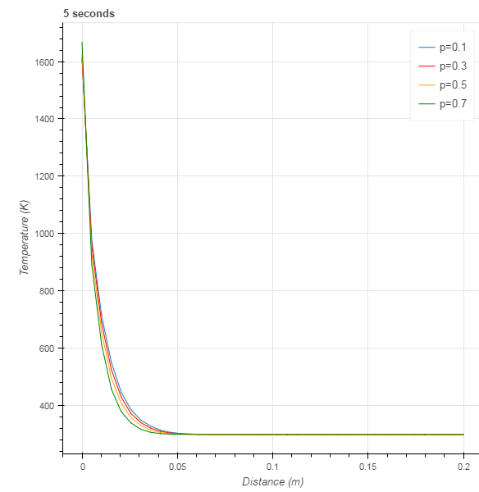

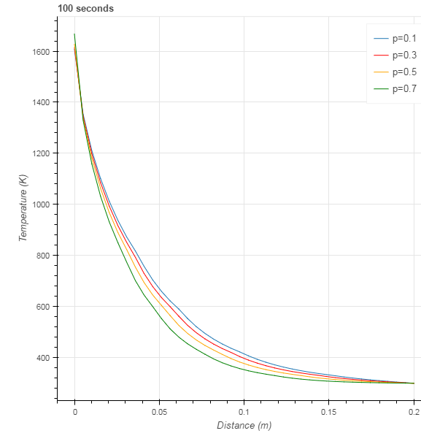

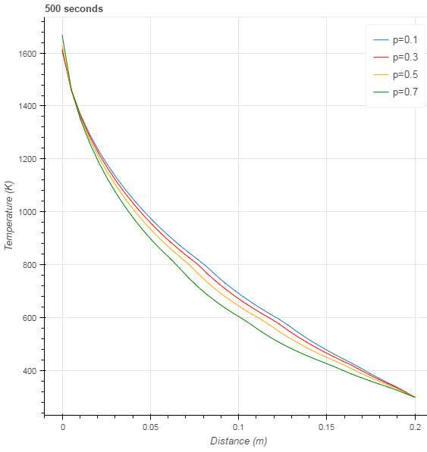

# Discussion

Slight numerical issues are caused due to the linearization process, which can be seen as “sharp angles” at the transition points between the piecewise linear segments. Further investigation would be required to remove them while retaining the piece-wise linear approach. Such problems can be eliminated by using a smooth expression for the material properties. However, this makes calculation times longer, and makes the heat equation non-linear.

# References

1. Landolt-Börnstein - Group III Condensed Matter
2. Kingery, Introduction to Ceramics 2nd edition
3. Stephen Stackhouse, Lars Stixrude, Bijaya B. Karki, Thermal Conductivity of Periclase (MgO) from First Principles, Physical Review Letters, 2010
4. Litovsky E., Litovsky T., Shapiro M., Shavit A., Thermal conductivity dependence of MgO thermal insulation on porosity in temperature range 500-2000 K, in Third Symposium on Insulation Materials: Testing and Applications, ASTM, Quebec, Canada, pp. 292-306
5. K. Stephan and A. Laesecke, Thermal conductivity of fluid air, Journal of Physical and chemical reference data, 14,227, 1985
6. Latif M Jiji, Heat conduction, 3rd edition, 2009, ISBN 978-3-642-01267-9